**Data Scientist Vs Data Analyst Vs Data Engineer**

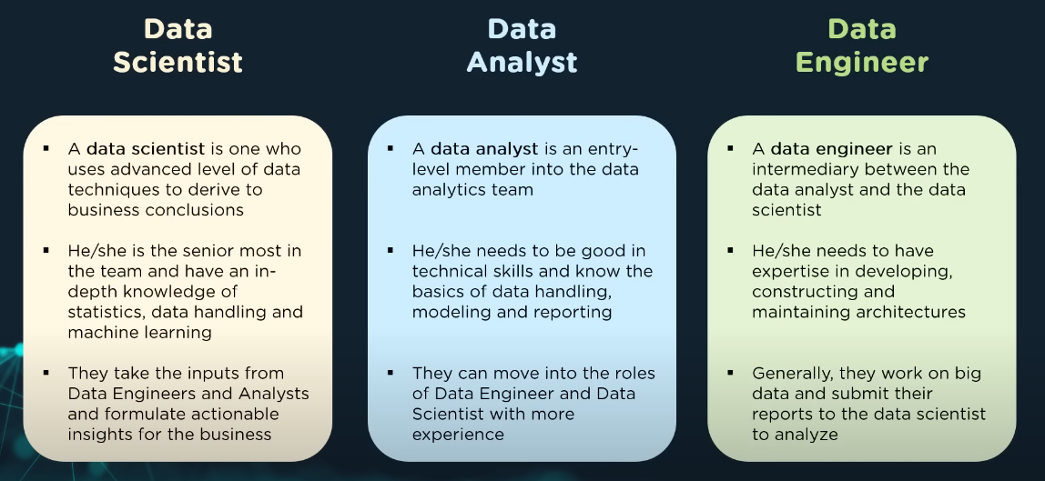

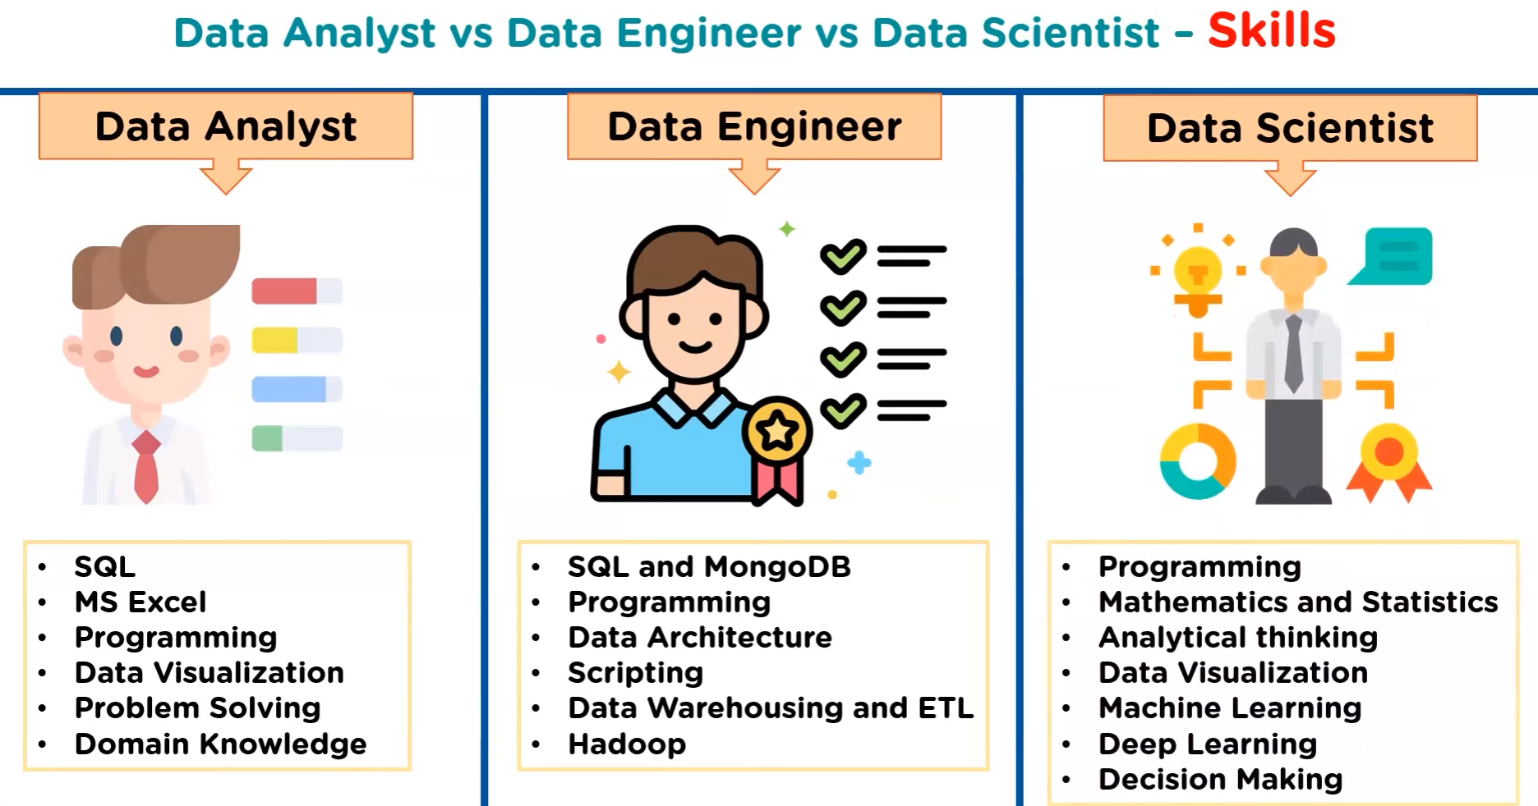

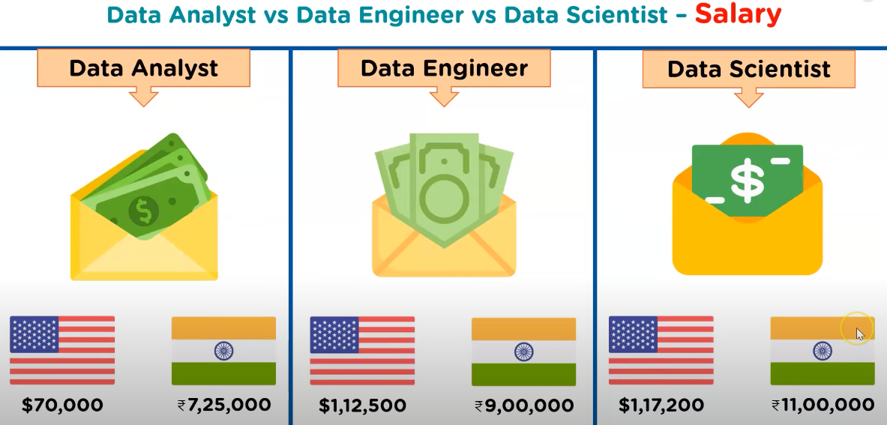

**What is Data ?**

Data is nothing but facts and statistics stored or free flowing over a network, generally it's raw and unprocessed. For example: When you visit any website, they might store you IP address, that is data, in return they might add a cookie in your browser, marking you that you visited the website, that is data, your name, it's data, your age, it's data.

Data becomes information when it is processed, turning it into something meaningful. Like, based on the cookie data saved on user's browser, if a website can analyze that generally men of age 20-25 visit us more, that is information, derived from the data collected.

**What is Database?**

Database is a collection of organized data in way that can be easily accessed , managed and updated. Database can be of software based or hardware based.

**Categories of Database :**

Software Based Databases are:

MySQL Workbench , Mongodb, Microsoft azure SQL database, oracle, IBM db2, Postgre SQL.

Hardware Based Databases are:

Flash storage 🡪 eg. Pendrives , microchips etc.

**Types of databases?**

1. **Centralized Databases :** A centralized database is like a single vault of information, all stored in one place and accessed by many.

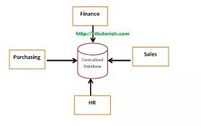

**Eg**. Disadvantage:

* Bottle Neck Kind……Speed and processing power becomes less….Takes Requests fast but responds slowly
  + Less Reliable/trustworthy as if central database fails , our whole data will be lost

Eg. Dekstop or Server CPU

1. **Distributed Databases :** A distributed database system is a collection of multiple , Logically related database over a network, that are physically distributed.

Advantage : Its Most Reliable/most trustworthy , as if one system fails .. then data may be retrieved from other system …in this system there is no bottle neck concept

Better response, Less communication cost , Easily expandable

Eg. Amazon Web Service

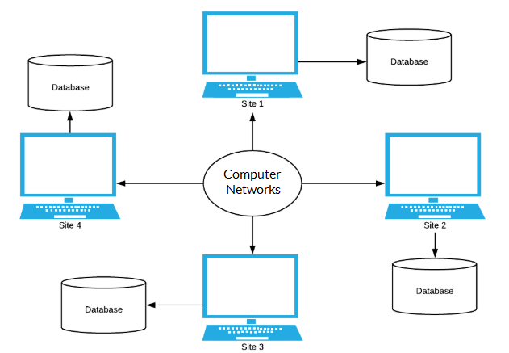

1. **Object Oriented Database :** In Object Oriented Databse, Real word problems are represented as object , with different attributes . All these objects have multiple relationship between them.

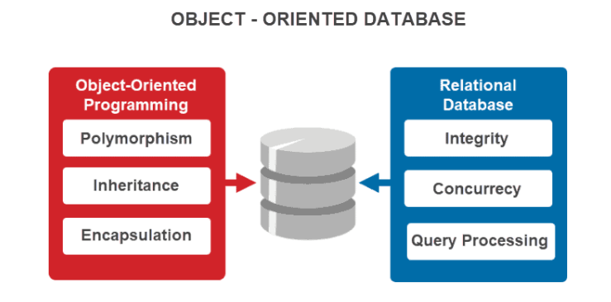

Example : **Call detail records (CDRs):** OODBs manage massive amounts of call data for billing, customer analysis, and network planning purposes, handling complex relationships between subscribers, calls, services, and network resources.

Trading positions etc

1. **Cloud Database :** A cloud database is a database that is hosted on a cloud computing platform, such as **Amazon Web Services, Microsoft Azure, or Google Cloud Platform**. It enables users to store, manage, and access data through the Internet. The data is stored in a remote server
2. **Network Database :** A network database is a database on a network containing information accessible by multiple clients through a network at the same time. It is similar almost similar to hierarchical databse

Eg. Follows Child-parent relationship , CRM (customer relationship management system.)

1. **NoSQL Database :** As its name suggests , Not only SQL as storing data in a tabular format it mainly stores data in a dictionary format which is a kind of key value pair .

**Document Oriented database –** A types of database used to store data as JSON like document

**Wide-Column Storage –** Similar to Relational Databases , here data is stored in large column together , instead of storing in rows.

**Eg:**- MongoDB , Cassendra

1. **Relational Databases :** A relational databases are the databases which stores data in a tabular format like in the form of rows and columns , maintaining a sequential relationship among data.

**eg.** Microsoft SQL Server, Oracle Database, MySQL, IBM DB2,SQlite3,PostgreSQL

**Terminologies used in Relational Databases**

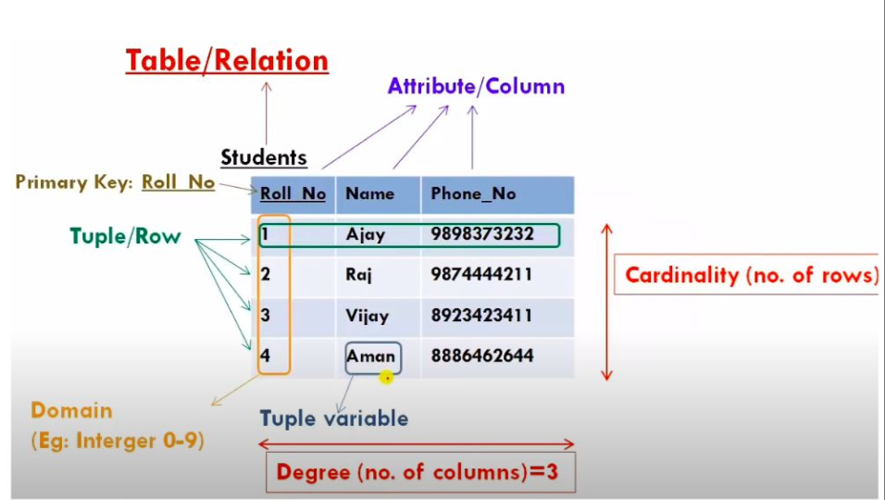

**Rows** -🡪Tuple/ Record

**Columns -**🡪Attributes (characteristics of data stored in a column)/ Field

**Schema** -🡪 Column Names or a database schema is a logical representation of data.

**Domain** -🡪 A set of an atomic values that are allowed for an attributes, Domain also specifies the data type allowed to a particular tuple.

**Atomic values** : Each Value in that domain is not divisible further

**Eg**. Name, Id, Age ( Possible ages of employee of a company is allowed between 20-70 )

**Database management system (DBMS)**

**What is DBMS ?**

A DBMS is a software that allows creation, deletion and manipulation of database, allowing users to store, process and analyse data easily. DBMS provides us with an interface or a tool, to perform various operations like creating database, storing data in it, updating data, creating tables in the database and a lot more.

DBMS also provides protection and security to the databases. It also maintains data consistency in case of multiple users.

**eg.** MongoDB , Apache Cassendra , Microsoft SQL Server .

**Advantages of DBMS:**

* Minimal data Duplicacy or data redundancy.
* Easy retrieval of data using the Query Language.
* Reduced development time and maintainance need.

**Disadvantages of DBMS:**

It's Complexity, They are large in size

* Except MySQL, which is open source, licensed DBMSs are generally costly.

|  |  |  |  |
| --- | --- | --- | --- |
| **s.no** | **DBMS** | **s.no** | **RDBMS** |
| 1 | Stores data as file | 1 | Stores data in tabular form |
| 2 | Normalization is not here | 2 | Normalization can be performed |
| 3 | Distributed database is not supported | 3 | Distributed database is supported |
| 4 | We have to follow the hierarchical manner to extract the data | 4 | We can directly find the data |
| 5 | Relation can’t be shown as data stored in file system | 5 | Relation can be shown as data stored in Tabular form |
| 6 | .xml, MongoDB | 6 | MySQL, Postgre SQL etc |

**Normalization –** It is a technique to remove or reduce redundancy/duplicacy from table.

**SQL Data Types**

Data types are used to represent the nature of the data that can be stored in the database table.

Data types mainly classified into **three** categories for every database.

* 1. String Data types
  2. Numeric Data types
  3. Date and time Data types

1. String Data types :
2. **VARCHAR(Size):** It is used to specify a variable length string that can contain numbers, letters, and special characters. Its size can be from 0 to 65535 characters.
3. **TEXT(Size):** It holds a string that can contain a maximum length of 255 characters.
4. **CHAR(size) :**

* Range: 1 to 2000 bytes
* This datatype is used to store alphabetical string of fixed length.
* Its value is quoted in single quotes.

|  |  |  |  |
| --- | --- | --- | --- |
|  | Char |  | Varchar |
| 1 | Provides Fixed length storage | 1 | Provides variable length storage |
| 2 | Occupies all the spaces,& if space is remaining then it filles all the blank spaces with “white space”. | 2 | Occupies only requires length and release  Remaining. |
| 3 | In terms of SPACE it is not better than varchar | 3 | In terms of spaces, it is better than char |
| 4 | Because of Fixed length nature it provides faster performance | 5 | Slower than Char |

1. Numeric Data types :
2. INT(size): It is used for the integer value. Its signed range varies from -2147483648 to 2147483647 and unsigned range varies from 0 to 4294967295. The size parameter specifies the max display width that is 255.
3. FLOAT(size, d): It is used to specify a floating point number. Its size parameter specifies the total number of digits. The number of digits after the decimal point is specified by d parameter.
4. DECIMAL(size, d): It is used to specify a fixed point number. Its size parameter specifies the total number of digits. The number of digits after the decimal parameter is specified by d parameter. The maximum value for the size is 65, and the default value is 10. The maximum value for d is 30, and the default value is 0.
5. DOUBLE(size, d):It is a normal size floating point number. Its size parameter specifies the total number of digits. The number of digits after the decimal is specified by d parameter.
6. BOOL:It is used to specify Boolean values true and false. Zero is considered as false, and nonzero values are considered as true.

**Float Vs Double Vs Decimal :**

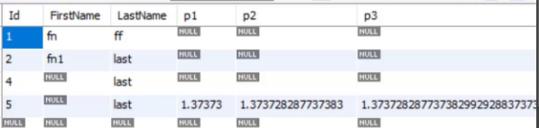

1. Date and Time Data Types
2. DATE: It is used to specify date format YYYY-MM-DD. Its supported range is from '1000-01-01' to '9999-12-31'.
3. DATETIME(fsp) : It is used to specify date and time combination. Its format is YYYY-MM-DD hh:mm:ss. Its supported range is from '1000-01-01 00:00:00' to 9999-12-31 23:59:59'.
4. TIMESTAMP(fsp): It is used to specify the timestamp. Its value is stored as the number of seconds since the Unix epoch('1970-01-01 00:00:00' UTC). Its format is YYYY-MM-DD hh:mm:ss. Its supported range is from '1970-01-01 00:00:01' UTC to '2038-01-09 03:14:07' UTC.
5. TIME(fsp): It is used to specify the time format. Its format is hh:mm:ss. Its supported range is from '-838:59:59' to '838:59:59'
6. YEAR: It is used to specify a year in four-digit format. Values allowed in four digit format from 1901 to 2155, and 0000.

**SQL Constraints**

SQL constraints are used to specify rules for the data in a table.

If there is any violation between the constraint and the data action, the action is aborted.

The following constraints are commonly used in SQL:

* 1. NOT NULL - Ensures that a column cannot have a NULL value
  2. UNIQUE - Ensures that all values in a column are different
  3. PRIMARY KEY - A combination of a NOT NULL and UNIQUE. Uniquely identifies each row in a table
  4. FOREIGN KEY - Prevents actions that would destroy links between tables
  5. CHECK - Ensures that the values in a column satisfies a specific condition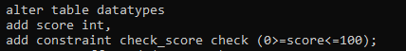
  6. DEFAULT - Sets a default value for a column if no value is specified

**What is SQL ?**

SQL stands for Structured Query Language and is a computer language that we use to interact with a relational databases. SQL is a tool for organizing, managing, and retrieving data from database. The original name was given by IBM as Structured English Query Language, abbreviated by the acronym SEQUEL.

RDBMS which supports SQL : **Mysql, Oracle, Infomix, Sybase, MS Access**

**Types of Database Languages or SQL commands :**

1. DDL Commands (Data Definition Language)
2. DML Commands ( Data Manipulation Language)
3. DCL Commands ( Data Control Language )
4. TCL Commands ( Transaction Control Language )
5. DQL Commands ( Data Query Language )
6. **DDL( Data Definition Language ) :-** This includes changes to the structure of the table like creation of table, altering table, deleting a table etc.
7. Create ------ Creates new table or database

Syntax : - create database databasename;

CREATE TABLE table_name

(

column_Name1 data_type ( size of the column ) ,

column_Name2 data_type ( size of the column) ,

column_Name3 data_type ( size of the column) ,

...

column_NameN data_type ( size of the column )

) ;

1. Alter -------- For alteration
   * 1. Syntax to add a newfield in the table:

ALTER TABLE name_of_table ADD column_name column_definition;

* + 1. Syntax to remove a column from the table:

ALTER TABLE name_of_table DROP Column_Name_1 , column_Name_2 , ….., column_Name_N;

* + 1. Syntax to modify the column of the table:

ALTER TABLE table_name MODIFY ( column_name column_datatype(size));

1. Drop -------- To drop a table
2. Truncate --- Delete Data from table

**DBMS Keys :**

A DBMS key is an attribute or a set of attributes which help you uniquely identify a record or a row of data in relation(Table).

Types of Keys :

1. Primary key
2. Composite key
3. Candidate key
4. Alternate key
5. Super kye
6. Foreign key
7. Unique key
8. Primary Key : Primary key is a candidate key that is most appropriate to become the main key for any table. It is a key that can uniquely identify each record in a table.

Primary key is choosen from set of candidate keys.

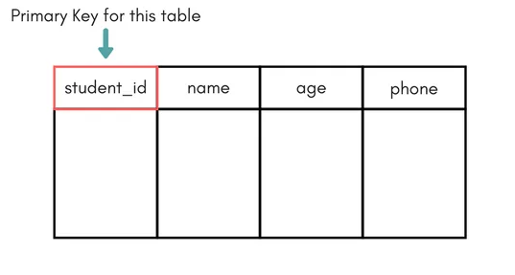

1. Composite key : A composite key is a combination of two or more columns in a table that can be used to uniquely identify each row in a table.

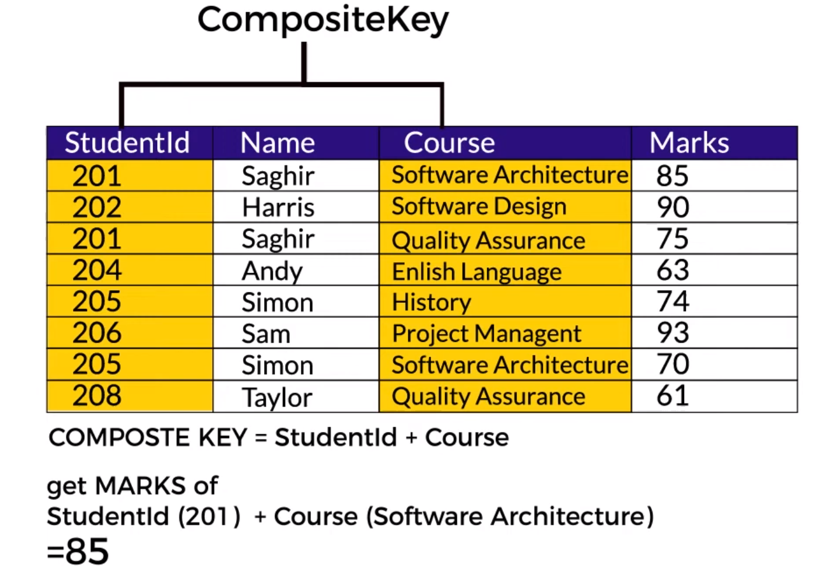

1. Candidate key : A candidate key SQL is a column or a set of columns that can qualify as a primary key in the database. There can be multiple SQL candidate keys in a database relation and each candidate can work as a primary key for the table.
2. Alternative key or Secondary key : The candidate key which are not selected as primary key are known as secondary keys or alternative keys.

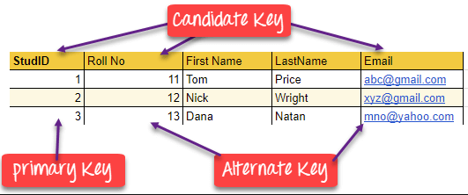

1. Super Key : A super key is a combination of all possible attributes which can uniquely identify two tuples in a table . or Super set of any candidate key is a super key.

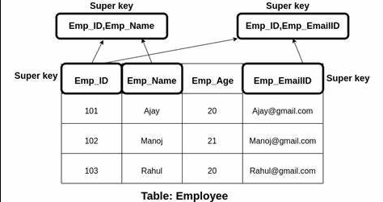

f ) **Foreign key :** foreign key is the one that is used to link two tables together or create connectivity between the two.

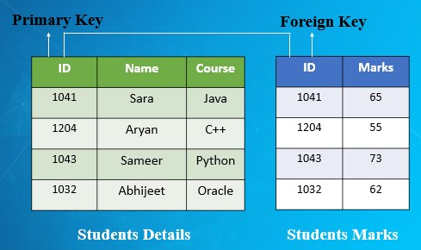

G ) Unique key : Unique Key is a column or set of columns that uniquely identify each record in a table.

It can have one null value but primary key can not have any null value.

1. **DML Commands ( Data Manipulation Language ) :** Used to manipulate the data present in Table/Relation.

Type of DML commands :

1. Insert s
2. Update
3. Select
4. Delete

A ) Insert Syntax: - INSERT INTO table_name VALUES (value1, value2, value3);

B ) Update Syntax : - UPDATE table_name SET column1 = value1, column2 = value2,…

C ) Select Syntax :- Select * from table name;

**Distinct , limit , offset Keywords**

D ) Delete Syntax :- DELETE FROM table_name WHERE some_condition;

**SQL Operators –** An operator is a symbol that tells the compiles/interpreter to perform specific mathematical , relational, or logical operation to produce a desired result

**What is an Expression :** An expression is a combination of one or more operators and operands which together produce a meaning full result

**Operand :** An operand is an object which is operated upon by any operator to produce a result.

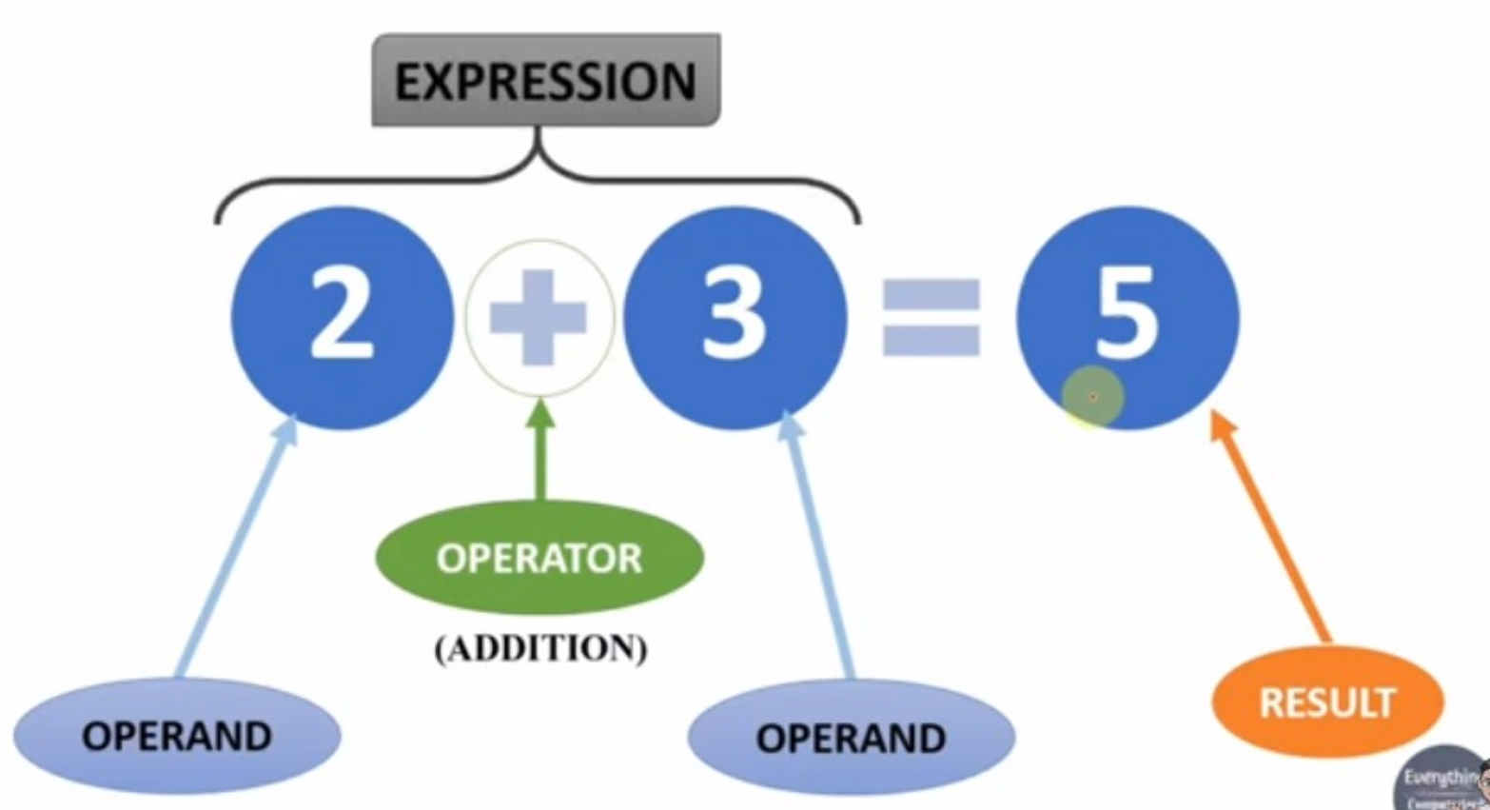

**Types of operators:**

1. **Arithmatic –-- ( +, -, *, /, %)**
2. **Comparison –--( < , > , <= , >= , <> or != , = )**
3. **Bitwise –--------- ( & , | , ^ )**
4. **Logical ----------- ( and , or , like , between , in)**

**Bitwise Operators –** They Compare each bit of the operand to the corresponding bit of the operand and produce final result.

Everything in a computer language is binary, An binary numbers consists of zeroes an ones , these zeroes and ones are knows a bits

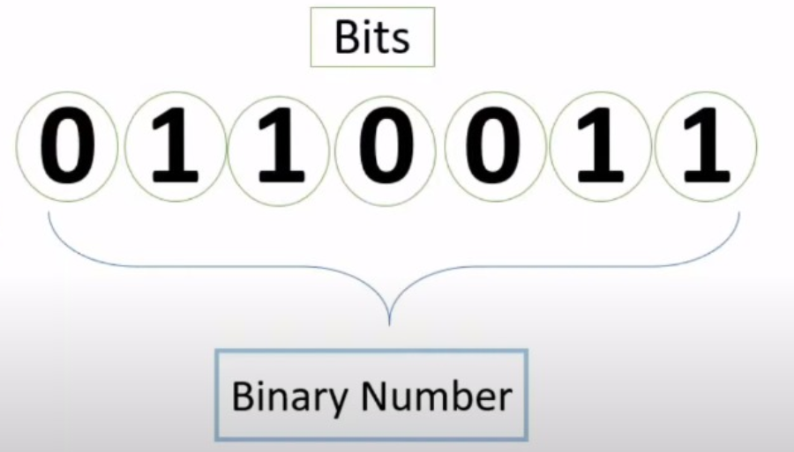

**Working of Bitwise operator**

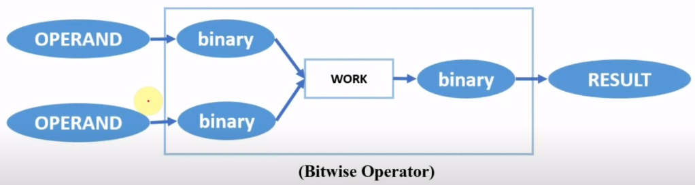

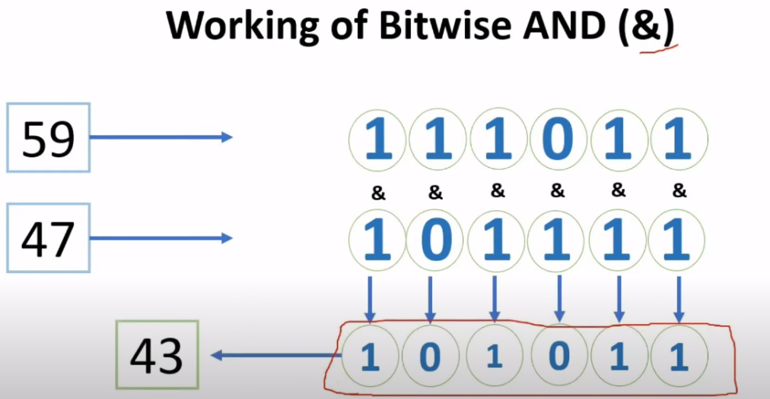

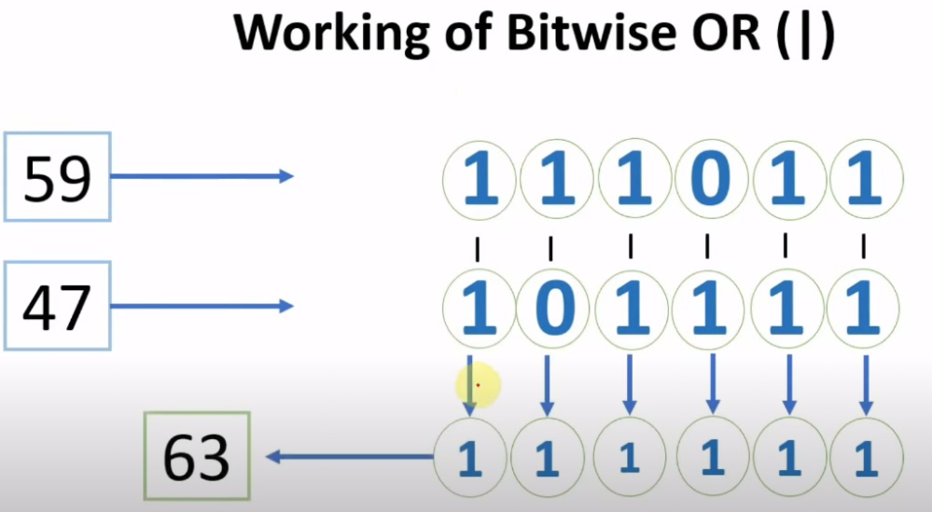

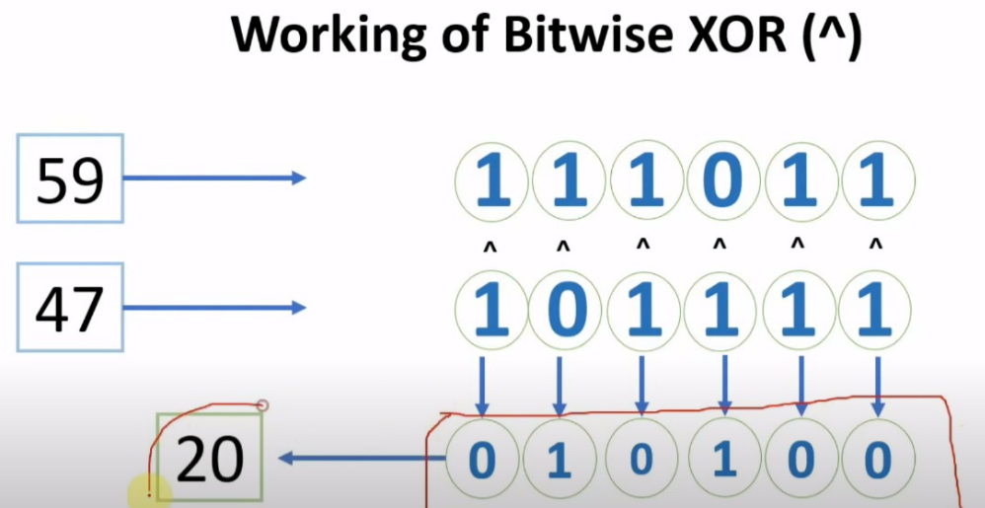

**Logical Operators**

The logical operators connect two or more boolean expressions such that the result of the compound expression depends on the result of the original expression and on the meaning of the operators

-- Results are in True and false

In & Not in Operators in SQL

Operators which can test a list of values

IN, NOT IN , BETWEEN , NOT BETWEEN

Understanding ALL, ANY/SOME, Exists in SQL

All , ANY/SOME keywords are used with the where/having clause. All , Any/Some operates on subqueries that return multiple values.

All returns true if all of the subquery values meet the condition , ANY/SOME returns true if ANY/SOME of the subquery values meet the condition .

**Union & Union All operators or Set Operations in SQL :**

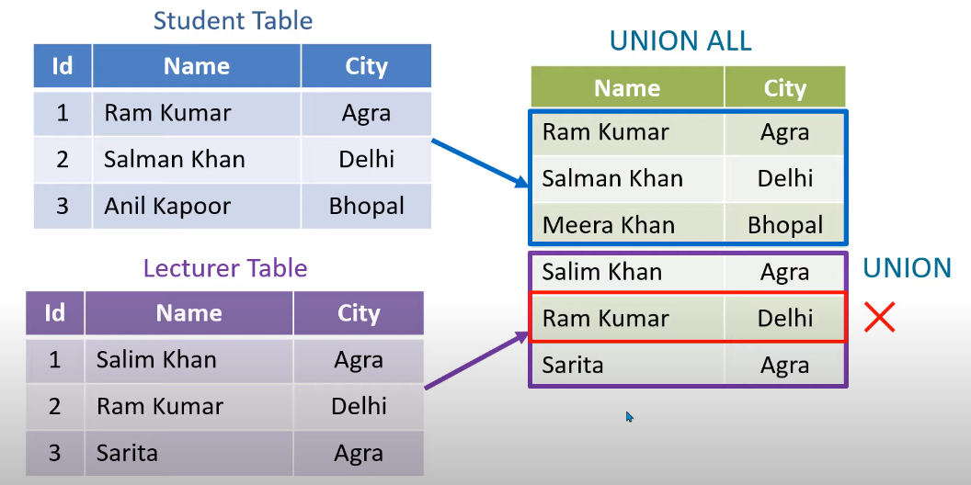

Syntax of Union & Union All :

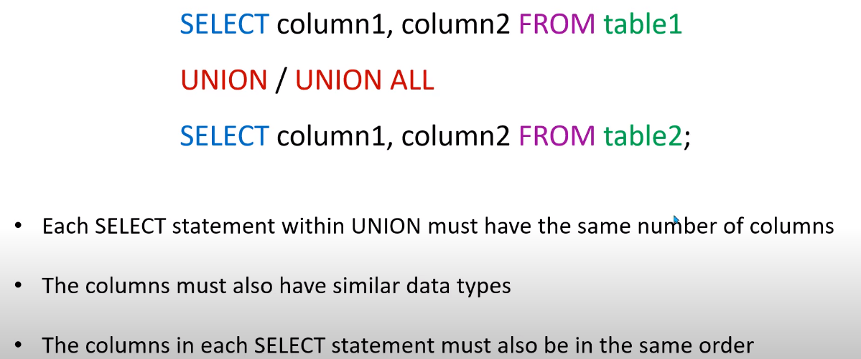

**Aggregate Functions Or SQL inbuilt Functions:**

These functions return a single value after performing calculations on a group of values

Eg – avg(), count(), max(), min() , sum(), Lcase(), Ucase() , Round() , Mid(name,start,end)

**SQL Alias - AS Keyword :**

Alias is used to give an alias name to a table or a column, which can be a resultset table too. This is quite useful in case of large or complex queries. Alias is mainly used for giving a short alias name for a column or a table with complex names.

Syntax of Alias for table names,

SELECT column-name FROM table-name AS alias-name

Eg : SELECT * FROM Employee_detail AS ed;

SELECT customer_id AS cid FROM Emp;

**SQL CLAUSES**

SQL clause helps us to retrieve a set or bundles of records from the table.

SQL clause helps us to specify a condition on the columns or the records of a table.

Different clauses available in the Structured Query Language are as follows:

1. WHERE CLAUSE
2. GROUP BY CLAUSE
3. HAVING CLAUSE
4. ORDER BY CLAUSE

Group By Clause

* + Group by clause is utilized with the select statement.
  + In SQL, Group by clause is one the tool to summarize or aggregate the data series.
  + The group by statement in SQL is used to arrange identical data into groups.
  + Group by typically also involves aggregate: Count, Max , Sum , Avg etc

Syntax :

Select Column_name

From table_name

Where Condition

Group by Column_name

Order by column_name;

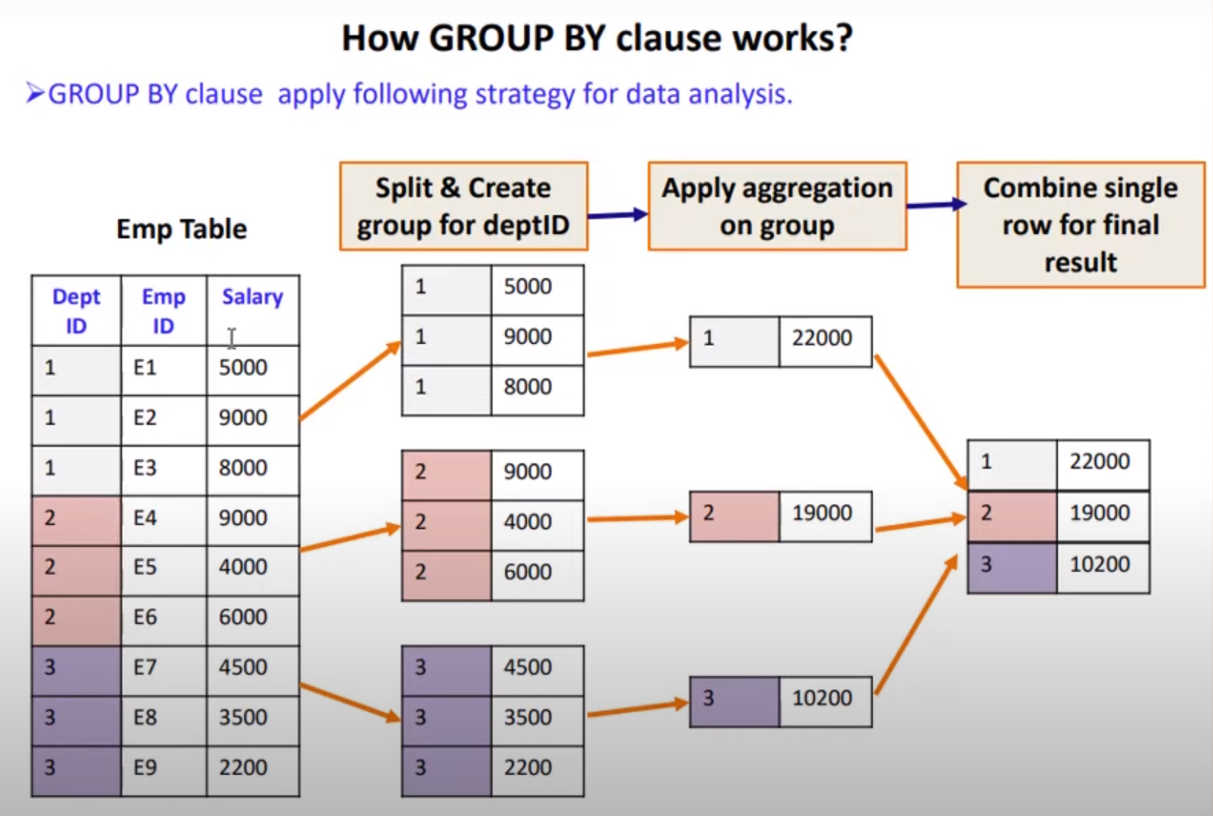

|  |  |  |  |
| --- | --- | --- | --- |
| **s.no** | **WHERE clause** | **s.no** | **HAVING clause** |
| 1 | used to filter the records from the table based on the specified condition | 1 | used to filter records from the groups based on the specified condition |
| 2 | Implemented in row operation | 2 | implemented in column operation |
| 3 | Can be used without GROUP BY clause | 3 | Can’t be used without Group by clause |
| 4 | Can be used with SELECT, UPDATE, DELETE statement | 4 | Can only be used with SELECT statement |
| 5 | Doesn’t contain aggregate function | 5 | Contains aggregate functions |
| 6 | Filters rows before grouping performed | 6 | Filters rows after grouping is performed |
| 7 | Group by clause is used after Where C. | 6 | Group by clause is used before Having C. |

SQL JOIN

The SQL Join help in retrieving data from two or more database tables. The tables are mutually related, using primary keys and foreign keys.

Type of Join

1. **INNER JOIN –** Returns rows when there is a match in both tables.

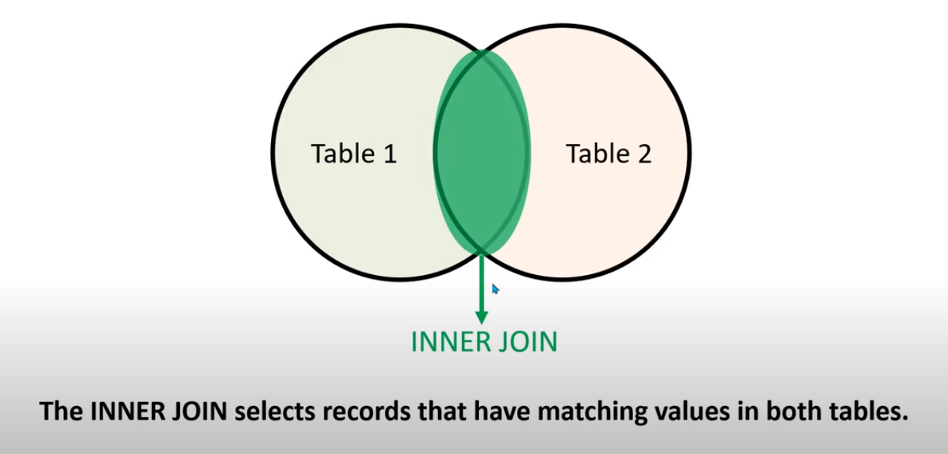

1.1 EQUI JOIN in SQL

Equi Join in SQL is a type of INNER Join that displays the output by performing a join operation between two or more tables based on the common column between them. It uses the equality ( = ) symbol to compare the data between two columns

1.2 NON-EQUI JOIN in SQL

Non-Equi Join is also a type of INNER Join in which we need to retrieve data from multiple tables. Non-Equi Join matches the column values from different tables based on an inequality based on the operators like <,>,<=,>=,!=, BETWEEN, etc.

1.3 Natural Join

Natural Join in SQL joins two tables based on the same attribute name and datatypes. The resulting table will contain all the attributes of both tables but keep only one copy of each common column.

|  |  |  |  |
| --- | --- | --- | --- |
| **s.no** | **Natural Join** | **s.no** | **Inner Join** |
| 1 | Natural Join joins two tables based on same attribute name and datatypes. | 1 | Inner Join joins two table on the basis of the column which is explicitly specified in the ON clause. |
| 2 | In Natural Join, The resulting table will contain all the attributes of both the tables but keep only one copy of each common column | 2 | In Inner Join, The resulting table will contain all the attribute of both the tables including duplicate columns also |
| 3 | In Natural Join, If there is no condition specifies then it returns the rows based on the common column | 3 | In Inner Join, only those records will return which exists in both the tables |
| 4 | Syntax-  SELECT *  FROM table1 NATURAL JOIN table2; | 4 | Syntax-  SELECT *  FROM table1 INNER JOIN table2 ON table1.Column_Name= table2.Column_Name; |

1. **Outer – Join** 
   1. LEFT OUTER JOIN – Returns all rows from the left table, and only matched data from the right table.
   2. RIGHT OUTER JOIN – Returns all rows from the right table, and only matched data from the left table
   3. FULL OUTER JOIN – Returns rows when there is a match in one of the table.
2. **SELF JOIN** - is used to join a table to itself as if the table were two tables, temporarily renaming at least one table in the SQL statement.
3. **CROSS JOIN –** Produces a result set which is the number of rows in the first table multiplied by the number of rows in the second table. This kind of result is called as cartesian product.

Window Functions:

<https://www.youtube.com/watch?v=S1do1EeA7ng>

* **Window functions** applies aggregate, ranking and analytic functions over a particular window (set of rows).
* And **OVER** clause is used with window functions to define that window.
* EXPRESSION is the name of the column that we want the window function operated on. This may not be necessary depending on what window function is used.
* PARTITION BY divides the rows into partitions so we can specify which rows to use to compute the window function
* ORDER BY is used so that we can order the rows within each partition. This is optional and does not have to be specified.
* ROWS can be used if we want to further limit the rows within our partition. This is optional and usually not used.

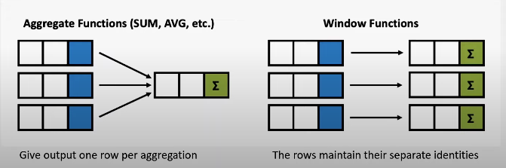

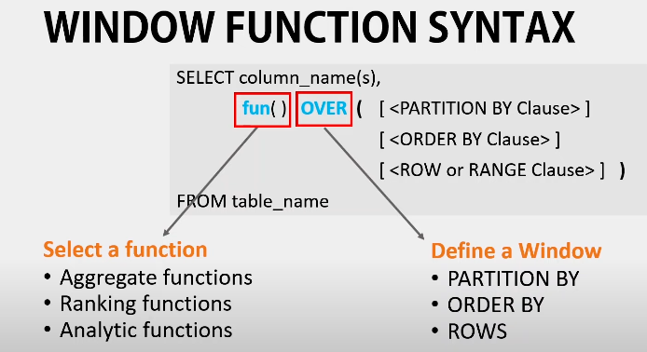

Most used Window functions

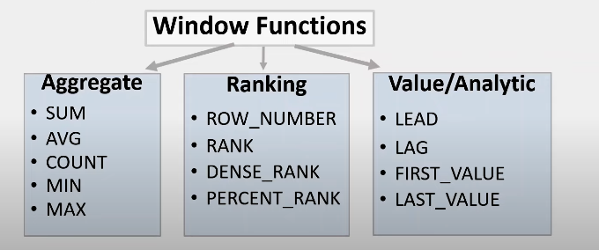

Normalization in DBMS

Removing duplicacy or redundancy from the table is called normalization

Normalization helps in keeping data consistent by storing the data in one table and referencing it anywhere else.

Problems without Normalization in DBMS

Insertion, Updation, and Deletion Anomalies are very frequent if the database is not normalized.

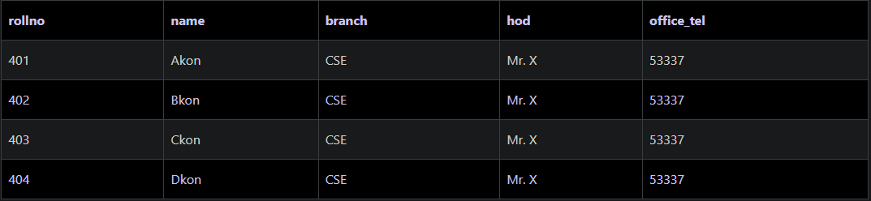

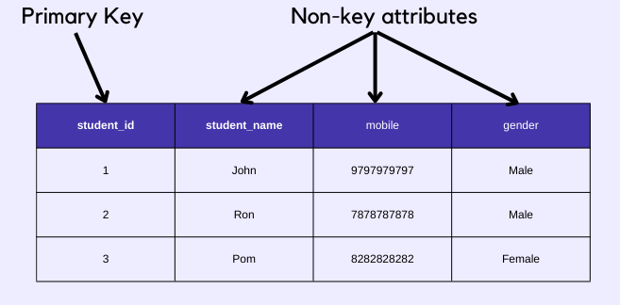

Non – Prime/Key attributes are those which are not participating in the formation of primary key.

Types of DBMS Normal forms

Normalization rules are divided into the following normal forms:

1. First Normal Form
2. Second Normal Form
3. Third Normal Form
4. BCNF(BOYCE CODE NORMAL FORM)
5. Fourth Normal Form
6. Fifth Normal Form
7. 1st Normal Form

It should only have single(atomic) valued attributes/columns. Values stored in a column should be of the same domain.

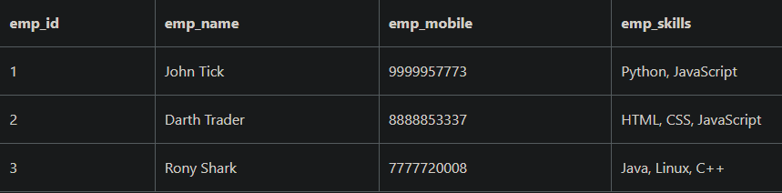

1. Create Separate tables for Employee and Employee Skills

Employee Table

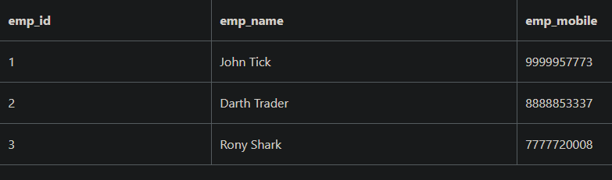

Employee_Skill table:

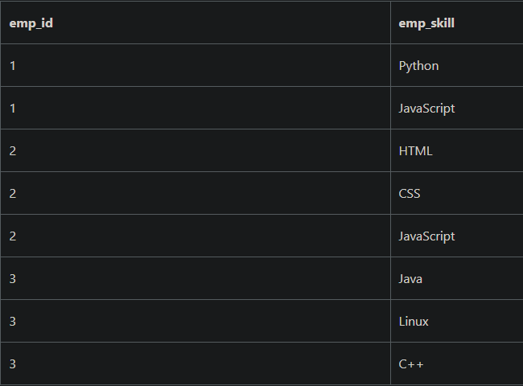

1. Add Multiple rows for Multiple skill

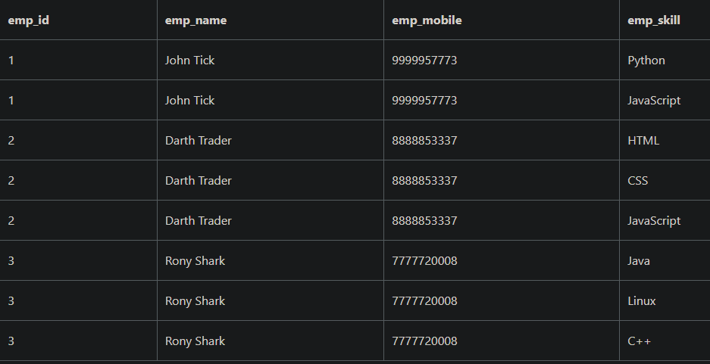

1. Second Normal Form (2NF)

For a table to be in the Second Normal Form,

* It should be in the First Normal form.
* And, it should not have Partial Dependency.

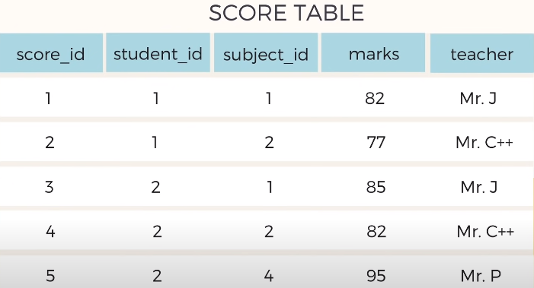

Here teacher is partially dependent ..because it only belongs to subjects ..although the score_id is primary key her but we can make best primary key by combining student_id + subject_id ..

To Remove partial dependency from this table , we should remove teacher column from score table and add it to the subject table

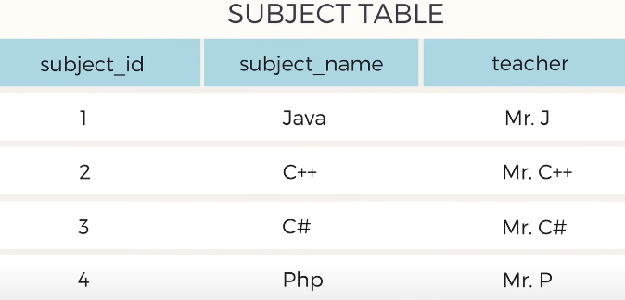

Now the table is in 2NF

<https://www.youtube.com/watch?v=R7UblSu4744>

1. Third Normal Form (3NF)

Table is said to be in the Third Normal Form when,

* It satisfies the First Normal Form and the Second Normal form.
* And, it doesn't have Transitive Dependency.

SCORE TABLE

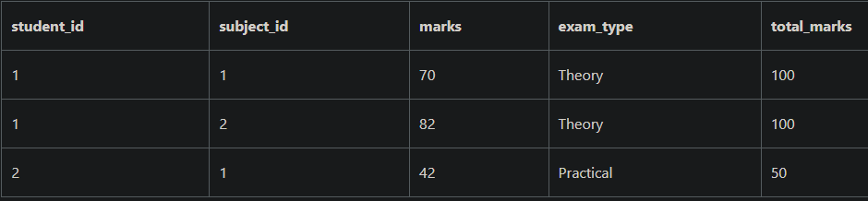

How to Transitive Dependency?

You can create a separate table for ExamType and use it in the Score table.

New Exam_Type table,

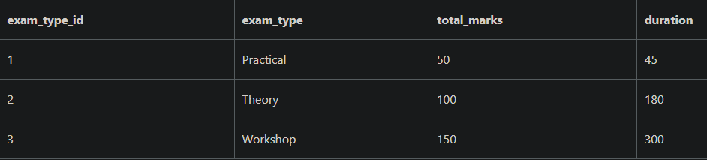

1. Boyce-Codd Normal Form (BCNF)

* Boyce and Codd Normal Form is a higher version of the Third Normal Form.
* This form deals with a certain type of anomaly that is not handled by 3NF.
* A 3NF table that does not have multiple overlapping candidate keys is said to be in BCNF.
* For a table to be in BCNF, the following conditions must be satisfied:

1. R must be in the 3rd Normal Form
2. and, for each functional dependency ( X → Y ), X should be a Super Key.

**Data Models**

* Data models define how the logical structure of a database is modelled.
* 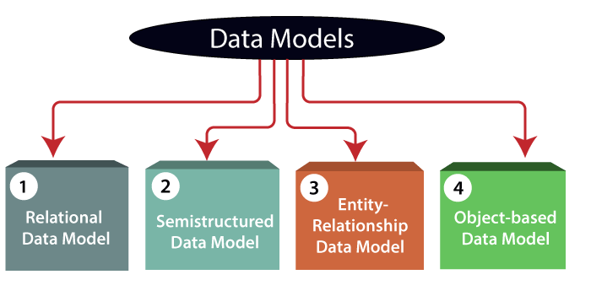Data models define how data is connected to each other and how they are processed and stored inside the system.

**Why use Data Model?**

* Ensures that all data objects required by the database are accurately represented.
* Omission of data will lead to creation of faulty reports and produce incorrect results.
* A data model helps to design the database at the conceptual, physical and logical levels.
* Data Model structure helps to define the relational tables, primary and foreign keys and stored procedures.
* It provides a clear picture of the base data and can be used by database developers to create a physical database.
* It is also helpful to identify missing and redundant data.
* Though the initial creation of data model is laborious and time consuming, in the long run, it makes your IT infrastructure upgrade and maintenance cheaper and faster.

**Types of Data Model**

1)Relational Data Model:

* This type of model designs the data in the form of rows and columns within a table.

Thus, a relational model uses tables for representing data and in-between relationships.

* Tables are also called relations.
* This model was initially described by Edgar F. Codd, in 1969.
* The relational data model is the widely used model which is primarily used by commercial data processing applications.

2) Entity-Relationship Data Model:

* An ER model is the logical representation of data as objects and relationships among them.
* These objects are known as entities, and relationship is an association among these entities.
* This model was designed by Peter Chen and published in 1976.
* It was widely used in database designing.
* A set of attributes describe the entities.
* For example, student_name, student_id describes the 'student' entity.
* A set of the same type of entities is known as an 'Entity set', and the set of the same type of relationships is known as 'relationship set'.

3) Object-based Data Model:

* An extension of the ER model with notions of functions, encapsulation, and object identity.
* This model supports a rich type system that includes structured and collection types.
* In 1980, various database systems following the object-oriented approach were developed.
* Here, the objects are nothing but the data carrying its properties.

**4) Semi-structured Data Model:**

* This type of data model is different from the other three data models.
* The semi-structured data model allows the data specifications at places where the individual data items of the same type may have different attributes sets.
* The Extensible Markup Language, also known as XML, is widely used for representing the semi-structured data.
* Although XML was initially designed for including the markup information to the text document, it gains importance because of its application in the exchange of data.

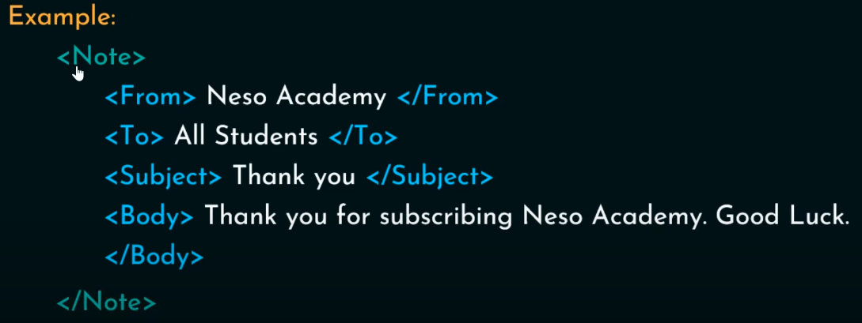

**ER Modelling**

* An Entity–relationship model (ER model) describes the structure of a database with the help of a diagram, which is known as Entity Relationship Diagram (ER Diagram).
* An ER model is a design or blueprint of a database that can later be implemented as a database.
* It develops a conceptual design for the database.
* The main components of E-R model are: entity set and relationship set.
* An ER diagram shows the relationship among entity sets.
* An entity set is a group of similar entities and these entities can have attributes.
* In terms of DBMS, an entity is a table or attribute of a table in database, so by showing relationship among tables and their attributes, ER diagram shows the complete logical structure of a database.

**Example**

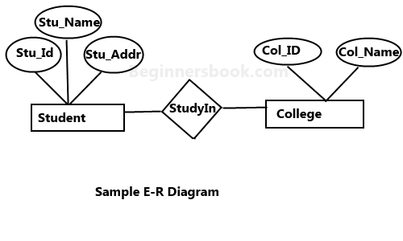

**Components of ER Diagram**

* Entity
* Attribute
  + Single valued(id)
  + Multivalued attribute(mobile No.,E-mail_id)
  + Composite attribute(name=fname+lname)
  + Derived attribute(age)
* Relation
  + One to one
  + One to many
  + Many to one
  + Many to many

**Entity**

* An entity may be any object, class, person or place.
* In the ER diagram, an entity can be represented as rectangles.
* Consider an organization as an example- manager, product, employee, department etc. can be taken as an entity.

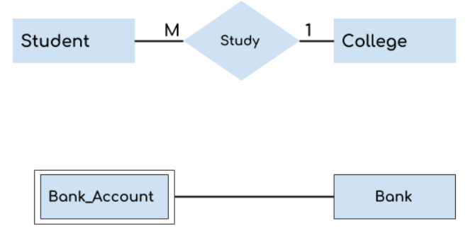

**Attribute**

* The attribute is used to describe the property of an entity. Eclipse is used to represent an attribute.
* 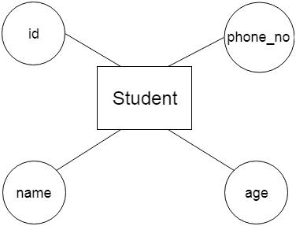For example, id, age, contact number, name, etc. can be attributes of a student.

**Types of attributes**

1. Key attribute  
2. Simple and Composite attribute  
3. Single Valued and Multivalued attribute  
4. Derived attribute

**Key Attribute**

* A key attribute can uniquely identify an entity from an entity set.
* For example, student roll number can uniquely identify a student from a set of students.
* Key attribute is represented by oval same as other attributes however the text of key attribute is underlined.

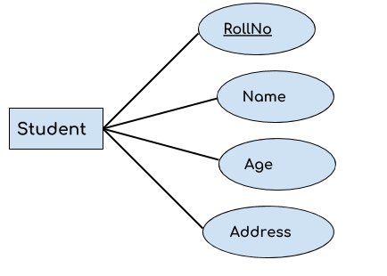

**Simple and Composite attribute:**

* If an attribute cannot be divided into simpler components, it is a **simple attribute**.
* Example for simple attribute : employee_id of an employee.
* An attribute that is a combination of other attributes is known as **composite attribute**.
* For example, In student entity, the student address is a composite attribute as an address is composed of other attributes such as pin code, state, country.

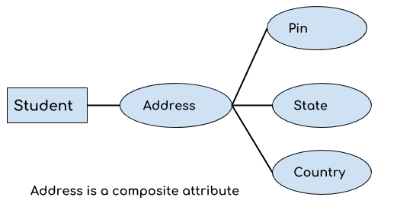

**Single and Multivalued attribute:**

* If an attribute can take only a single value for each entity instance, it is a **single valued attribute**. example for single valued attribute : age of a student. It can take only one value for a particular student.
* An attribute that can hold multiple values is known as **multivalued attribute**.
* It is represented with **double ovals** in an ER Diagram.
* 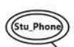For example – A person can have more than one phone numbers so the phone number attribute is multivalued.

**Derived Attribute :**

* A derived attribute is one whose value is dynamic and derived from another attribute.
* It is represented by dashed oval in an ER Diagram.
* For example – Person age is a derived attribute as it changes over time and can be derived from another attribute (Date of birth).

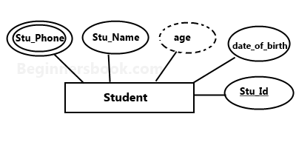

**Relationship**

* A relationship is represented by diamond shape in ER diagram, it shows the relationship among entities.
* There are four types of relationships:  
  1. One to One  
  2. One to Many  
  3. Many to One  
  4. Many to Many

**One to one relationship**

* When a single instance of an entity is associated with a single instance of another entity then it is called one to one relationship.

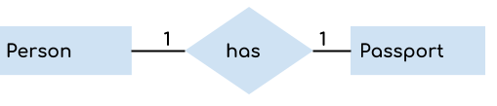

* For example, a person has only one passport and a passport is given to one person.

**One to Many Relationship**

* When a single instance of an entity is associated with more than one instances of another entity then it is called one to many relationship.
* For example – a customer can place many orders but a order cannot be placed by many customers.

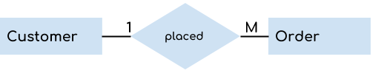

**Many to One Relationship**

* When more than one instances of an entity is associated with a single instance of another entity then it is called many to one relationship.
* For example – many students can study in a single college but a student cannot study in many colleges at the same time. 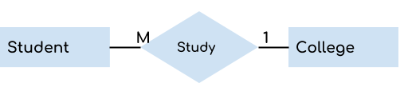

**Many to Many Relationship**

* When more than one instances of an entity is associated with more than one instances of another entity then it is called many to many relationship.
* 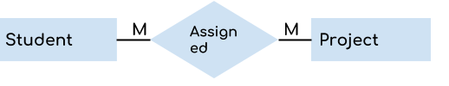For example, a student can be assigned to many projects and a project can be assigned to many students.

**Example-E-R diagram for hospital**

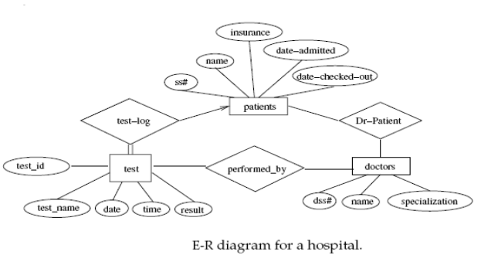

**Advantages and Disadvantages of ER Modeling**

* Advantages
  + ER Modeling is simple and easily understandable.
  + It is represented in business users language and it can be understood by non-technical specialist.
  + Intuitive and helps in Physical Database creation.
  + Can be generalized and specialized based on needs.
  + Can help in database design.
  + Gives a higher level description of the system
* Disadvantages
  + Physical design derived from E-R Model may have some amount of ambiguities or inconsistency.
  + Sometime diagrams may lead to misinterpretations

**DBMS Architecture** :

DBMS architecture describes the structure and how the users are connected to a specific database system.

There are mainly Three Types of database architectures

1. 1-Tier Architecture
2. 2-Tier Architecture
3. 3-Tier Architecture

Here Tier means number of layers

1. **1-Tier Architecture :**

User Can Directly use Database.

Eg. Ms-Office

1. **2-Tier Architecture:**

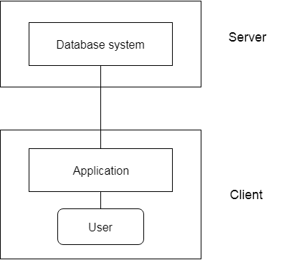

In 2 Tier architecture , User gives input to the API first then API directly access server side Database and gives the output to the client,

Security is less, less maintainance

Eg . Railway counter ticket booking system

1. **3-Tier Architecture :**

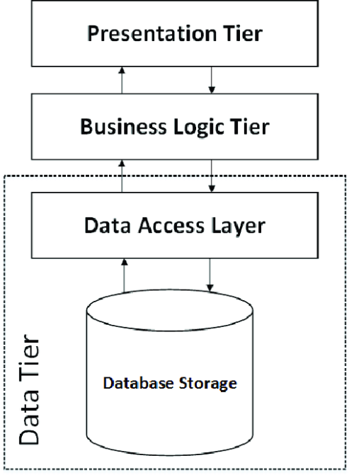

In 3 tier architectures .. client just gives input like mob number, OTP to API, then application programm is processed by the business layer , the business layer works as intermediate . eg. IRTC ticket booking

1. **DCL( Data Control Language ) :-** A Data Control Language or DCl , is a computer programming language, which is used to control user access to data stores in a database. This is a component of SQL which is related to the security issues of a database.

**There are two commands in the DCL :**

1 ) GRANT : - used to give permission to a user to access a database.

To allow an user to create table in a database

SYNTAX

GRANT CREATE ANY TABLE TO username ;

2 ) REVOKE : - Used to withdraw permission from a user to access a database.

To prevent an user from creating table in a database

REVOKE CREATE ANY TABLE TO username

Similarly from Droping the table.

**System operations** : - All the database system operations like Creating a database, Creating a table etc

**Object Operation :** - All the database table operation , such as viewing a table , altering a table etc.

1. **TCL( Transaction Control Language ) :-**

TCL is used to manage transaction in a database . This is used to manage changes made to the data in a table by DML statements . It allows statements to be grouped together into logical transaction

There are Three Commands in it

1 ) Commit : - used to save the changes made to the table permanentely

2 ) Rollback : - used to get back to the previous permanent status of the table , kind of similar to UNDO

Note : - Table can be rolled back only if it it temporary . If you committed your changes , it cannot be rolled by.

3 ) Savepoint : - Used along with the ROLLBACK command. It is used to mark a transaction in a table.

It is kind of similar to BOOKMARKS.

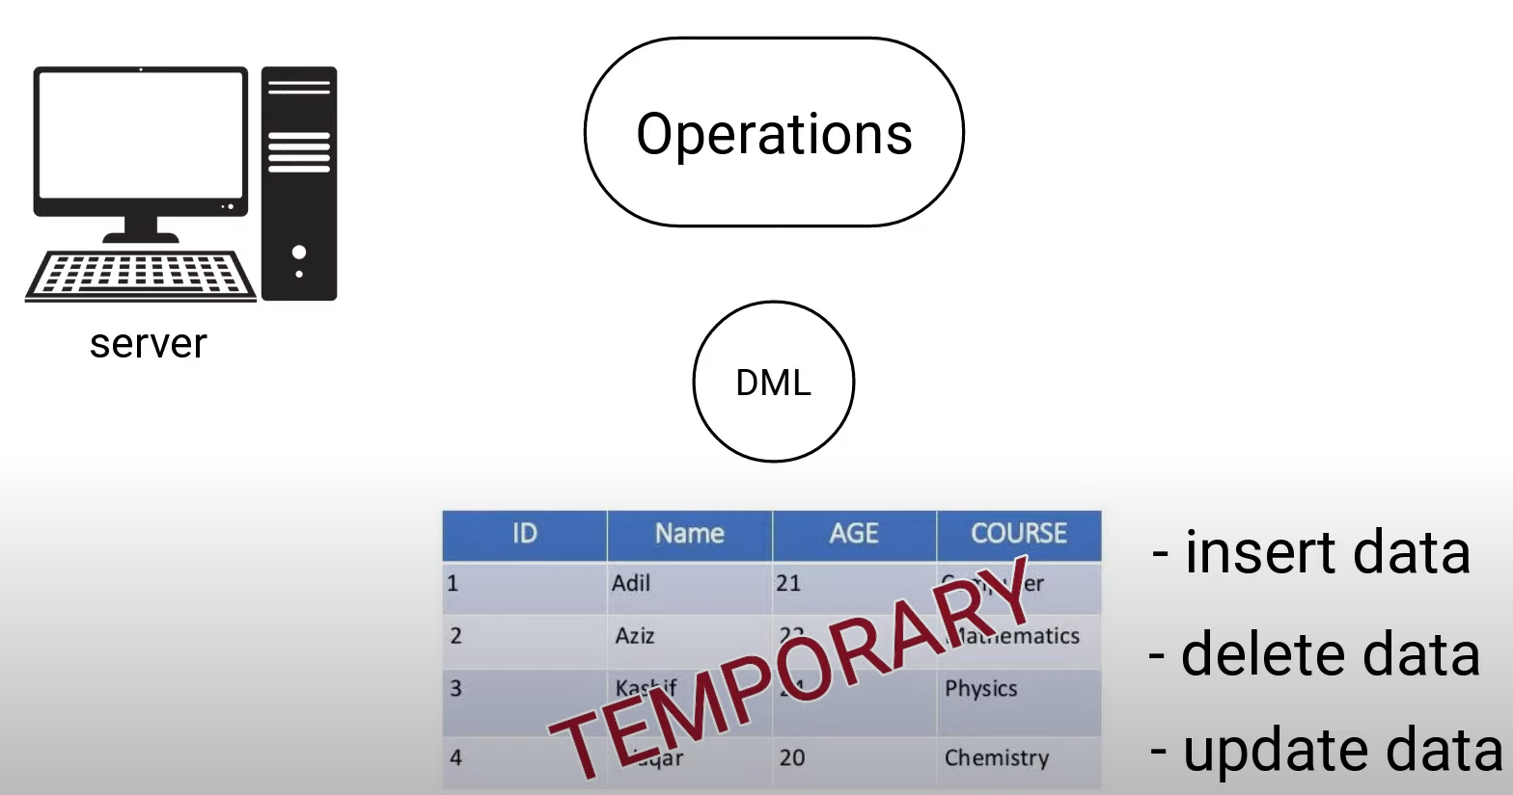

Application

1 ) Sorting 🡪 Ascending order , Descending order using order by.

2 ) Filtering 🡪 To fetch some values using operators like in, between , and , or

3 ) String Operation -🡪 replace() , like , char_length() , concat(), lower(), upper(), repeat() , reverse()

4 ) Math Operation 🡪 pi() , pow(), abs(), ceiling(), floor(), log(), sqrt(), mod()

SQL VIEW

* Virtual Table
* View is the result set of a stored query
* Read – only VS updatable views
* Materialized view

Base table and Views of table

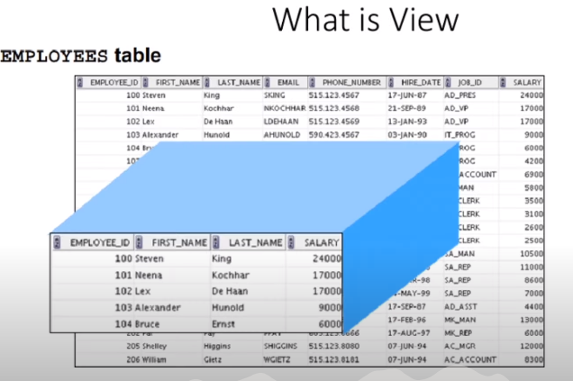

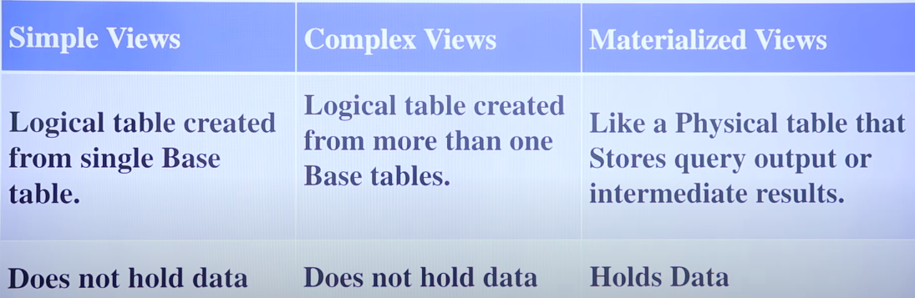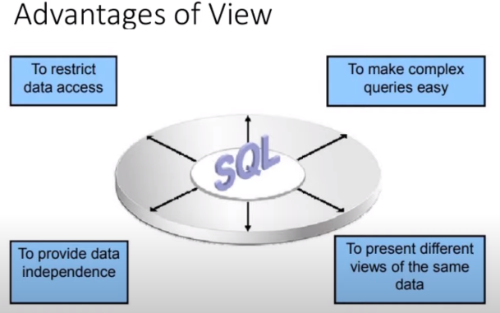

Simple view syntax:

Create view V1 as select * from Base_table_name:

Complex view syntax:

Create view V2 as select Id,Name,city from T1,T2 where T1.id = T2.id;

Materialized view syntax:

Create Materialized view V3 as select dept , max(salary) , min(salary) , average(salary) from T1 group by dept.

**Updatable View and Read only view:**

